Lesson 3 Demo 2: Top kubectl Commands

This section will guide you to:

* Use some of the top kubectl commands while working on any Kubernetes cluster

This lab has one sub-section, namely:

1. Using some of the top kubectl commands while working on any Kubernetes cluster

**Note:** If you don’t have an existing Kubernetes cluster, refer to the Demo 1.1 of Lesson 1.

**Step 1:** Using some of the top kubectl commands while working on any Kubernetes cluster

* Let's now see how to use some of the common kubectl commands.
* Let us take an example of the sample yaml file named *pod1.yaml* as shown below:

***cat > pod1.yaml***

*apiVersion: v1*

*kind: Pod*

*metadata:*

*name: nginx*

*labels:*

*name: nginx*

*spec:*

*containers:*

*- name: nginx*

*image: nginx*

*ports:*

*- containerPort: 80*

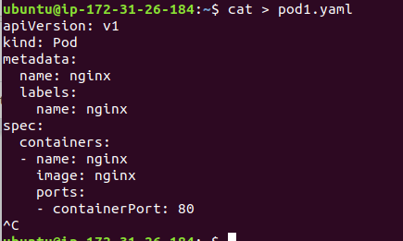

* **create** => Create a resource from a file or from stdin.

*kubectl create -f pod.yaml*



* **get** => Display one or many resources. For example: to print pods, use kubectl get command as shown below:

*kubectl get pods*

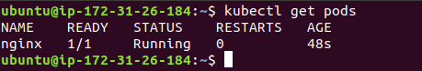

* **run** => Create and run an image, possibly replicated, as shown below:

*kubectl run nginx --image=nginx*



* **delete** => Delete the resources by filenames, stdin, resources and names, or by resources and label selector, as shown below:

*kubectl delete -f pod.yaml*

